Scrum Master Backend Report: Sprint 3 (September 4th – 10th)

Scrum Master: Ciar

Participants: Maki, Pyper, Jethro, Charles, Gray

# Meeting Notes for Planning:

* Meeting Date: 05/09/23
* Sprint goals:
  + We are aiming to complete (or almost complete) the application by the end of this sprint so that we have enough time allocated to testing for next week.
  + Development tasks have been allocated as such:
* Breakdown of tasks and roles:
  + Mern set up, system design document update & pull requests (Ciar)
  + Mern updates, CRUD functionality & pull requests (Maki)
  + Filter article results (Pyper)
  + Authorization and authentication (Jethro)
  + CSS Styling (Gray)
  + Assistance with CSS, authentication, and authorization (Charles)

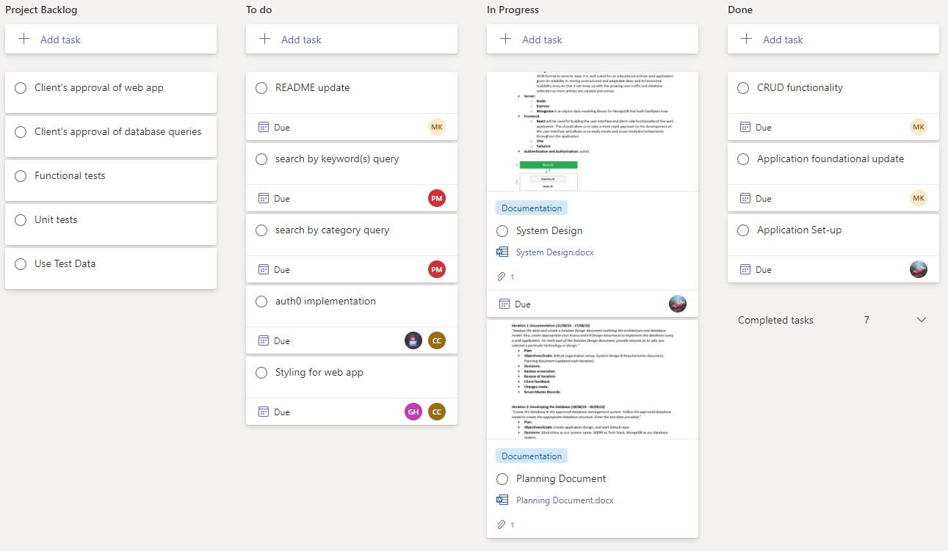

# Progress Updates throughout the Sprint:

# Retrospective Notes:

* Date: 11/09/2023
* Participants: Ciar, Pyper, Maki, Jethro, Gray, Charles

We have all spent the week finishing off any remaining documentation, developing our respective features of the application and ensuring that everything is being correctly merged in the GitHub repo. Unfortunately, due to a variety of reasons, most people were unavailable for the retrospective meeting last Friday so we have moved that today and combined it with the test plan for the next sprint.

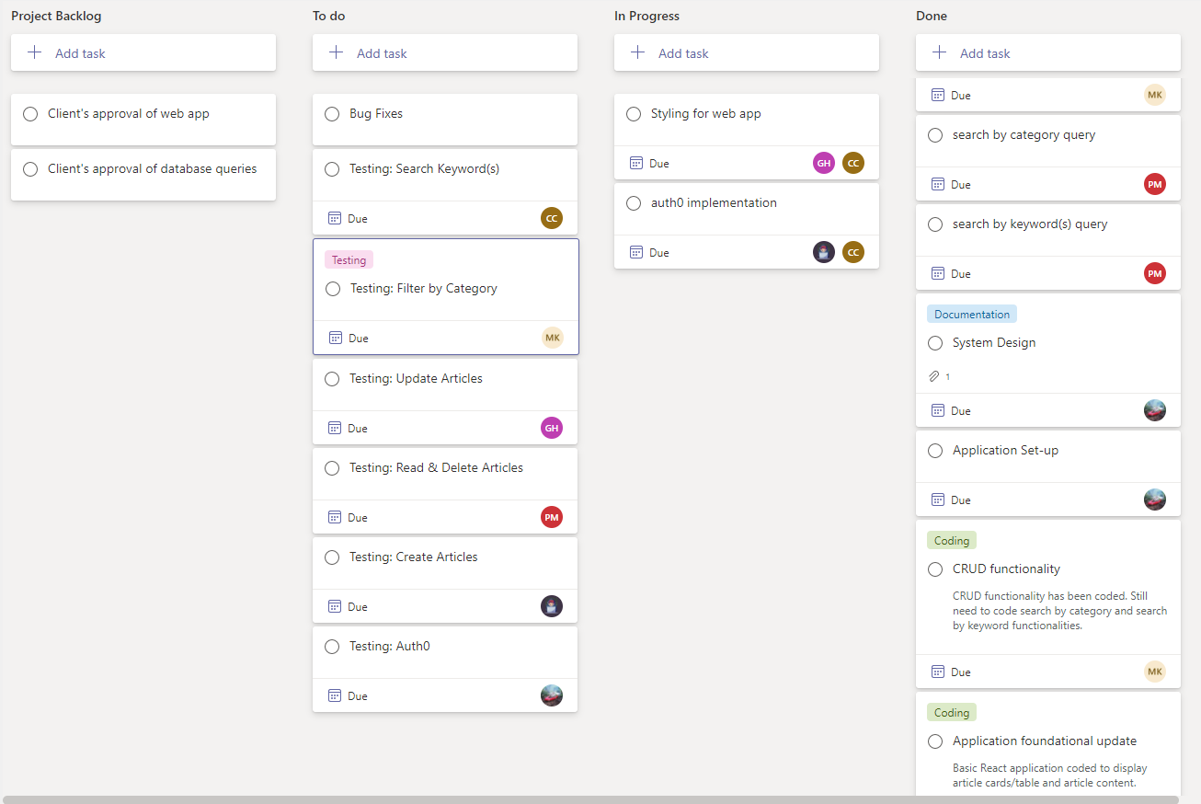

## Accomplished:

* The application has been set up, and a MERN stack has been implemented with some framework additions.
* Connection to database tested and secured.
* CRUD functionality has been completed.
* Filtering and searching for articles via specific criteria have been implemented.
* Documentation has been updated and completed.

## Not accomplished:

* Auth0 implementation with authorization and authentication features are still currently being implemented. As we are all unfamiliar with this third-party system, we will be continiously testing this as we move forward.
* CSS styling needs a bit more time, as there was some confusion regarding certain features, and we need to adapt this along with auth0.

## What went well?

* Having a clearly defined division of roles and task allocations made it easier to understand what our respective responsibilities were, and what we needed to get done by when.

## Action items for next sprint:

First, we will be finishing the implementation of features that were unable to be finished by the end of the sprint. We have included some of these features within expected bug features for the upcoming sprint.

Secondly, we have allocated a user story for each team member to test, so the action items for the next sprint will be focused on testing, bug fixing, and ensuring documents are ready for submission at the end of the sprint.